UNIT II
PROGRAMMING OF 8085 PROCESSOR

Instruction -format and addressing modes – Assembly language format – Data transfer, data manipulation& control instructions – Programming: Loop structure with counting & Indexing – Look up table - Subroutine instructions – stack
*****************************************************************************************

Instruction Format
  - Instruction:
- It is a command given to the microprocessor to perform given task on specified data.Each instruction has two parts viz. task to be performed known as operation code or opcode and second is the data to be operated upon known as operand.
- The Operand can be used in many different ways e.g. 8 bit data or 16 bit data or internal register or memory location or 8 bit or 16 bit address.
- 8085 Instructions can be classified based on the size they occupy in memory or by the functions they perform. Figure shows the classification of the instructions.

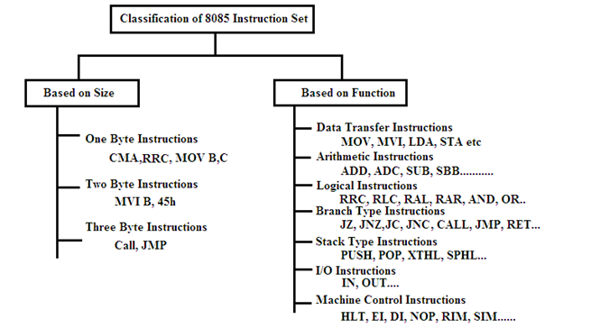
Fig: Classification of Instruction Set of 8085
**************************************************************************************
Discuss in detail about the 8085 instruction set and explaining about the various types of operation.[December 2013,April 2011,June 2016][April 2018]
************************************************************************************
1.1.Instruction Format
Based on the size, the instructions can be classified are as follows
One byte Instructions:
These instructions are of one byte in size and hence occupy one memory location in RAM. Examples are CMA, RLC, RRC, RAL, RAR, STC, CMC etc. These instructions do not require any operand to be specified with the instructions; instead the operand is implied in the instructions.

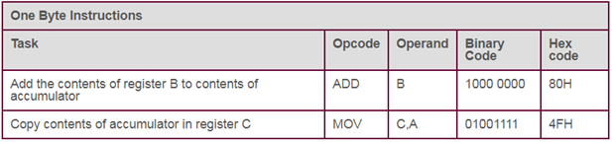
Two Byte Instruction:
These instructions of two byte (16-bits) in size and hence will occupy two memory locations in RAM. Examples of such instructions are MVI C, 0A;
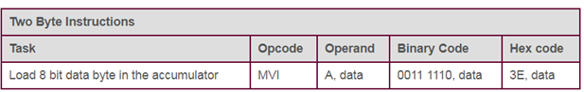
Three Byte Instructions:
These are of three byte in size and hence occupy three locations in memory (RAM). Examples of such instructions are CALL, JMP etc.

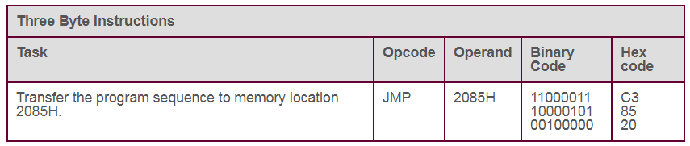

*****************************************************************************************
Explain the classification of Instruction set with example.
Explain logical instruction with example. (December 2015)
*****************************************************************************************
  - Instruction Set Classification
An instruction is a binary pattern designed inside a microprocessor to perform a specific function. The entire group of instructions, called the instruction set, determines what functions the microprocessor can perform.
These instructions can be classified into the following five functional categories:
- Data transfer (copy) operations,
- Arithmetic operations,
- Logical operations,
- Branching operations, and
- Machine-control operations.
1 Data Transfer Croup
The data transfer instructions move data between registers or between memory and registers.

- MOV Move
- MVI Move Immediate
- LDA Load Accumulator Directly from Memory
- STA Store Accumulator Directly in Memory
- LHLD Load H & L Registers Directly from Memory
- SHLD Store H & L Registers Directly in Memory

An 'X' in the name of a data transfer instruction implies that it deals with a register pair (16-bits);

- LXI Load Register Pair with Immediate data
- LDAX Load Accumulator from Address in Register Pair
- STAX Store Accumulator in Address in Register Pair
- XCHG Exchange H & L with D & E
- XTHL Exchange Top of Stack with H & L

2 Arithmetic Group
The arithmetic instructions add, subtract, increment, or decrement data in registers or memory.
- ADD Add to Accumulator
- ADI Add Immediate Data to Accumulator
- ADC Add to Accumulator Using Carry Flag
- ACI Add immediate data to Accumulator Using Carry
- SUB Subtract from Accumulator
- SUI Subtract Immediate Data from Accumulator
- SBB Subtract from Accumulator Using Borrow (Carry) Flag
- SBI Subtract Immediate from Accumulator Using Borrow (Carry) Flag
- INR Increment Specified Byte by One
- DCR Decrement Specified Byte by One
- INX Increment Register Pair by One
- DCX Decrement Register Pair by One
- DAD Double Register Add; Add Content of Register Pair to H & L Register Pair

3 Logical Group
This group performs logical (Boolean) operations on data in registers and memory and on condition flags. The logical AND, OR, and Exclusive OR instructions enable you to set specific bits in the accumulator ON or OFF.

- ANA Logical AND with Accumulator
- ANI Logical AND with Accumulator Using Immediate Data
- ORA Logical OR with Accumulator
- OR Logical OR with Accumulator Using Immediate Data
- XRA Exclusive Logical OR with Accumulator
- XRI Exclusive OR Using Immediate Data

The Compare instructions compare the content of an 8-bit value with the contents of the accumulator;
- CMP Compare
- CPI Compare Using Immediate Data

The rotate instructions shift the contents of the accumulator one bit position to the left or right:

- RLC Rotate Accumulator Left
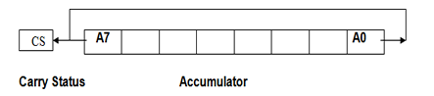
- RRC Rotate Accumulator Right
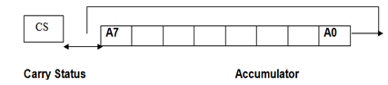
- RAL Rotate Left Through Carry
- RAR Rotate Right Through Carry

Complement and carry flag instructions:
- CMA Complement Accumulator
- CMC Complement Carry Flag
- STC Set Carry Flag
4 Branch Group
The branching instructions alter normal sequential program flow, either unconditionally or conditionally. The unconditional branching instructions are as follows:
- JMP Jump
- CALL Call
- RET Return

Conditional branching instructions examine the status of one of four condition flags to determine whether the specified branch is to be executed. The conditions that may be specified are as follows:

- NZ Not Zero (Z = 0)
- Z Zero (Z = 1)
- NC No Carry (C = 0)
- C Carry (C = 1)
- PO Parity Odd (P = 0)
- PE Parity Even (P = 1)
- P Plus (S = 0)
- M Minus (S = 1)

Thus, the conditional branching instructions are specified as follows:

Jumps Calls Returns
INC CNC RNC (No Carry)
JNZ CNZ RNZ (Not Zero)
JM CM RM (Minus)
JP0 CPO RPO (Parity Odd)
JM CM RM (Minus)
JPE CPE RPE (Parity Even)
JP0 CPO RPO (Parity Odd)

Two other instructions can affect a branch by replacing the contents or the program counter:

- PCHL Move H & L to Program Counter
- RST Special Restart Instruction Used with Interrupts
5 .Stack Instructions
The following instructions affect the Stack and/or Stack Pointer

- PUSH Push Two bytes of Data onto the Stack
- POP Pop Two Bytes of Data off the Stack
- XTHL Exchange Top of Stack with H & L
- SPHL Move content of H & L to Stack Pointer

6 .I/0 instructions
- IN Initiate Input Operation
- OUT Initiate Output Operation
7 Machine Control instructions

- EI Enable Interrupt System
- DI Disable Interrupt System
- HLT Halt
- NOP No Operation

*************************************************************************************************
Define addressing mode.Write the types of addressing modes with example.(December 2014)(December 2015) (April 2015)(April 2018)(Dec 2018)
*****************************************************************************************
3. Addressing Modes
Various ways of specifying the operands or various formats for specifying the operands is called addressing mode
- Implicit addressing
This mode doesn’t require any operand; the data is specified by the opcode itself.
- CMA – Complement the contents of accumulator
- Immediate addressing
In this mode, the 8/16-bit data is specified in the instruction itself as one of its operand.
- MVI B, 05H means 05 is copied into register B.
- ADI 06H
- Direct addressing –
In this mode, the data is directly copied from the given address to the register.
- STA 2400H, IN 02H
- STA 2400H means the data at address 2400 is copied to register A.

- Register addressing
In this mode, the data is copied from one register to another.
- MOV A, B
- ADD B
- Register indirect addressing
In this mode, the data is transferred from one register to another by using the address pointed by the register.
- LDAX B,
- STAX D
LDAX B means data is transferred from the memory address pointed by the register pair BC to the register A.
*****************************************************************************************
Write short notes on STACK and Subroutine
**************************************************************************************
- STACK:
Stack is an area of memory identified by the programmer for temporary storage of information.
- Stack is a LIFO structure.
- Stack normally grows backwards into memory-the programmer defines the bottom of the stack and the stack grows up into reducing address range.
- Stack is defined by setting the SP(stack pointer) register.LXI SP,FFFFH
- The size of the stack is limited only by the available memory.
- Information is saved on the stack by PUSHing it on.
- Information is retrieved from the stack by POPing it off.
- The 8085 provides two instructions:PUSH and POP for storing information on the stack and retrieving it back.
- Both PUSH and POP work with register pairs only.
PUSH instruction
EX: PUSH B
Steps to be followed for PUSH B one byte instruction
- Decrement SP
- Copy the contents of register B to the memory location pointed by SP.
- Decrement SP
- Copy the contents of register C to the memory location pointed to by SP.

POP instruction:
EX: POP D
Steps to be followed for POP D one byte instruction
- Copy the contents of the memory location pointed to by the SP to register E.
- Increment SP
- Copy the contents of the memory location pointed to by the SP to register D.
- Increment SP
Operation of the stack:
- During pushing, the stack operates in a ' decrement then store' style-The stack pointer is decremented first, then the information is placed on the stack
- During popping, the stack operates in a "use then increment' style.-The information is retrieved from the top of the stack and then the pointer is incremented.
- The SP pointer always points to the "top of the stack"
LIFO:
The order of PUSHs and POPs must be opposite of each other in order to retrieve information back into its original location.
PUSH B
PUSH D
.....
POP D
POP B
Reversing the order of the POP instructions will result in the exchange of the contents of BC and DE
PSW register pair:
The 8085 recognizes one additional register pair called the PSW(PROGRAM STATUS WORD). This register pair is made up of the accumulator and the flag registers.

***************************************************************************
Explain the use of lookup table in 8085.
***************************************************************************

- Lookup table

- A lookup table is an array that replaces runtime computation with a simpler array indexing operation.
- The savings in terms of processing time can be significant, since retrieving a value from memory is often faster than undergoing an 'expensive' computation or input/output operation.
- The tables may be pre-calculated and stored in static program storage, calculated (or "pre-fetched") as part of a program's initialization phase (memorization), or even stored in hardware in application-specific platforms.
- Lookup tables are also used extensively to validate input values by matching against a list of valid (or invalid) items in an array and, in some programming languages, may include pointer functions (or offsets to labels) to process the matching input.
Example of look up table Algorithm
1. Initialize HL pair to point Look up table
2. Get the data
3. Check whether the given input is less than 9
4. If yes go to next step else halt the program
5. Add the desired address with the accumulator content
6. Store the result
Program:
LXI H,5000 ;Initialsie Look up table address
LDA 5050 ;Get the data
CPI 0A ;Check input > 9
JC AFTER ;if yes error
MVI A,FF ;Error Indication
STA 5051
HLT
AFTER: MOV C,A ;Add the desired Address
MVI B,00
DAD B
MOV A,M
STA 5051 ;Store the result
HLT ;Terminate the program
LOOK UP TABLE:
5000 01
5001 04
5002 09
5003 16
5004 25
5005 36
5006 49
5007 64
5008 81

RESULT:
Input: Data : 05H in memory location 5050
Output: Data : 25H (Square of 5) in memory location 5051
Input: Data : 11H in memory location 5050
Output: Data : FFH (Error Indication) in memory location 5051

***************************************************************************************************************

Sample 8085 Assembly Programs
Example-1: Write assembly program to add two numbers. (December 2014)

MVI D, 8CH
MVI C, 6EH
MOV A, C
ADD D
OUT PORT1
HLT
Example-2: Write assembly program to multiply a number by 8
Multiply by 2 is equivalent to shifting.

MVI A, 40H
RLC
RLC
RLC
OUT PORT1
HLT
Example-2: Write assembly program to multiply two 8 bit number
 | MVI B, 07H
 | MVI C, 06H
 | XRA A
GO | ADD B
 | DCR C
 | JNZ GO
 | STA 4A00
 | HLT

Example-3: Write assembly program to find greatest between the two numbers.

MVI B, 30H
MVI C, 40H
MOV A, B
CMP C
JZ EQU
JC GRT
OUT PORT1
HLT
EQU: MVI A, 01H
OUT PORT1
HLT
GRT: MOV A, C
OUT PORT1
HLT
Write an assembly language program for to generate Fibannoci series using subroutines(Dec 2014)
MVI A,00
STA 8000
MVI A,01
STA 8001
MVI B,08
LXI H,8000
BACK: MOV A,M
INX H
ADD M
INX H
MOV M,A
DCR B
DCX H
JNZ BACK
HLT

Write an assembly language program for to multiply two 16 bit numbers. (June 2016)

 | LXIH, 0000
 | LXIB, 1CD2
 | LXI SP,01AD
 | LXI D, 0000
MUL | DAD SP
 | JNC DOWN
 | INX D
DOWN | DCX B
 | MOV A,B
 | ORA C
 | JNZ MUL
 | SHLD 4A00
 | XCH G
 | SHLD 4A02
 | HLT

Programming using subroutine Instructions
Generation of Square waveform using DAC
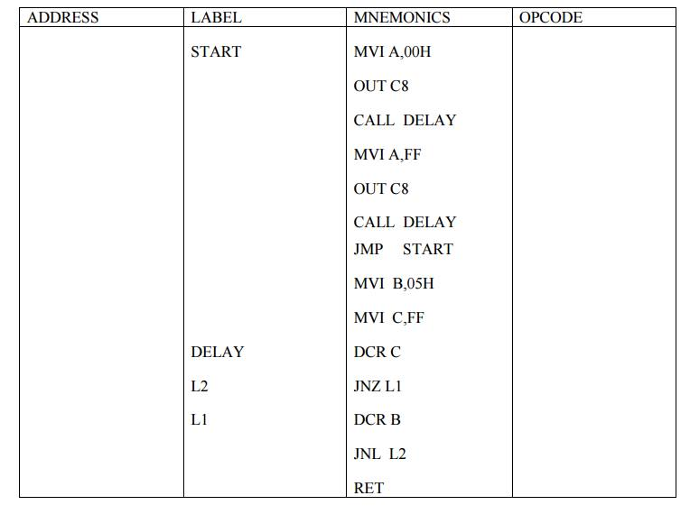
Programming using Loop structure with Counting and Indexing
(i) 16 bit Multiplication
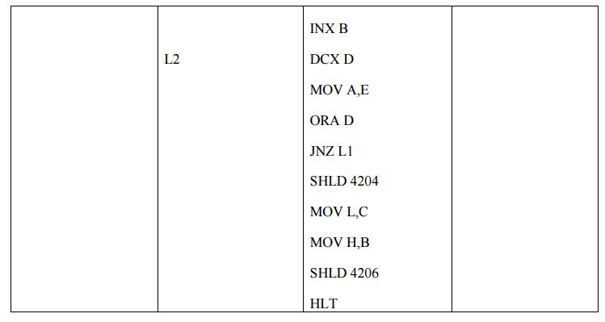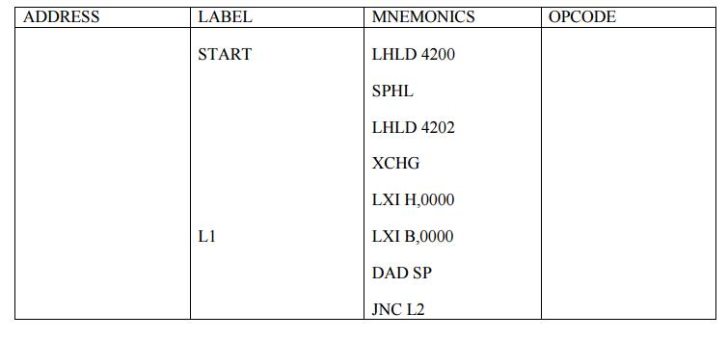

(ii)Finding the maximum number in the given array
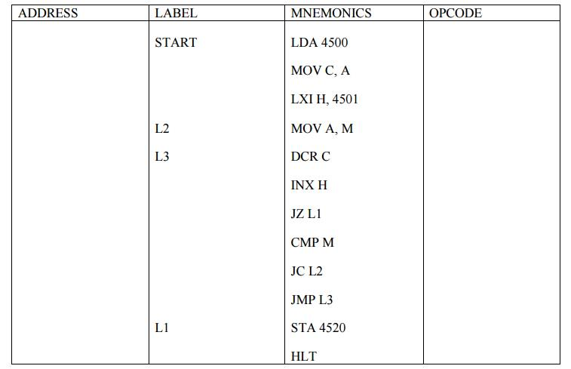
Develop an algorithm and 8085 assembly language program to sort 100 byte type data. Explain the instruction used in the program.(Dec 2018)

L3 MVI B,00
LXI H,4200
MOV C,M
INX H
DCR C
L2 MOV A,M
INX H
CMP M
JC L1
MOV D,M
MOV M,A
DCX H
MOV M,D
MVI B,01
L1 DCR C
JNZ L2
DCR B
JZ L3
HLT
INPUT
4200 99
4201 data1
…………….
4300 data 100

&&&&&&&&&&&&&&&&&&&&&&&&&&

